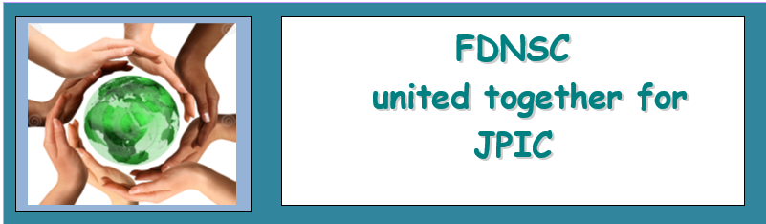
FDNSC Generalate, Rome JPIC Bulletin, No 1, May 2023
Letter from the editorial desk

Dear Sisters and Friends…..

We apologize for the delay in writing the JPIC Newsletter/Bulletin. It may be late, but we try to keep you updated. This is the first Bulletin of 2023. This newsletter is with the latest modified appearance, hopefully it will continue to be interesting to read. The table of contents in our bulletin is as follows:

Letter from the editorial desk

In this section, we will include a letter from the Generalate's editorial desk regarding JPIC. It can also be letters from readers of this newsletter, in the form of comments, messages and impressions from readers.

General Coverage:

This section will briefly include information regarding the results of the International Union of Superiors General (UISG) meeting and the results of the Tri-Generalate meeting on JPIC.

Our forums.

This issue’s forum covers all the latest activities in various Provinces, Regions and Local Communities related to JPIC.

This is how our bulletin will be presented. If you have additional input in the form of impressions, suggestions, or recommendations from friends, please feel free to write an email to this address: genco1@olshgen.org

Our newsletter will be published every 3 months. Happy reading!

GENERAL COVERAGE

Sister-led dialogue on the environment

PRESS RELEASE Sisters in dialogue with development community to safeguard the environment and people affected by climate change and biodiversity loss.
The first Sister-led dialogue on the environment is taking place today in Rome, launching a series of development dialogues organised by the International Union of Superiors General (UISG)

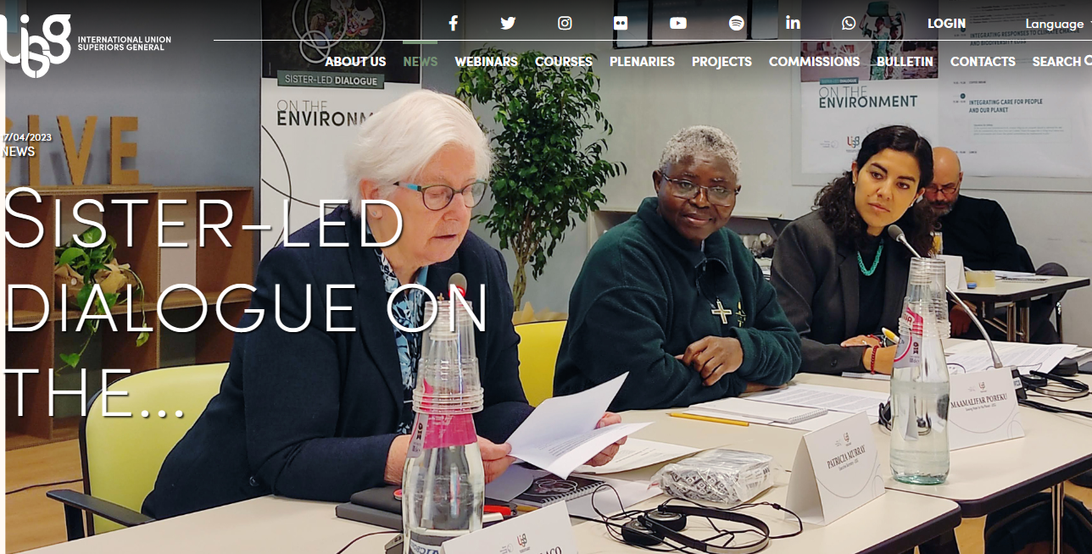Rome, 17th April 2023 – Ahead of Earth Day on April 22nd, Catholic Sisters of the International Union of Superiors General (UISG) are gathering partners in Rome to highlight and dialogue on global development issues. The organisation, which brings together more than 1,900 Superiors General in 97 countries, representing over 600,000 Sisters worldwide, is hosting its first Sister-led dialogue on the environment to discuss the protection of people affected by climate change and biodiversity loss, with particular attention to the most marginalised. Today’s encounter is the first in a series of dialogues organised by the UISG initiative Sisters Advocating Globally, in partnership with the Global Solidarity Fund. These dialogues will culminate in the first UISG Advocacy Forum, to be held in Rome in November 2023.

Today’s dialogue brings together representatives of international organisations, governments, civil society, Vatican institutions academia and the press from around the world to talk about three key themes: integrating responses to climate change and biodiversity loss; integrating care for people and our planet; integrating vulnerability in leadership. These three themes were outlined in the UISG statement “Sisters for the Environment: integrating voices from the margins”, launched last November ahead of the climate summit COP27. This statement is based on the experience of advocacy and community engagement that has coalesced around UISG’s environmental campaign Sowing Hope for the Planet, created for the promotion of Pope Francis’s encyclical Laudato Si’ and the UN Sustainable Development Goals. At the global level, UISG has integrated into its strategic plans a central commitment to safeguarding people on the margins who are affected by environmental degradation, which includes working towards the implementation of outcomes from COP27 and COP15. As bridge builders, Sisters bring others together with a focus on our common humanity, to walk towards a safe, just and peaceful future for all people and all Creation. This is what gathers us today at UISG, to dialogue and share ideas on promoting the creation of a healthy environment for all people on Earth”.

TRI-GENERALATE MEETING

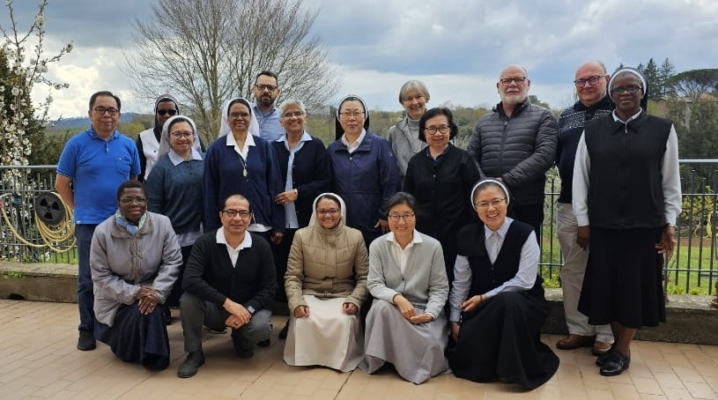
On April 5, 2023, the Tri-Generalate meeting was held in Sutri. This meeting was the first gathering after the General Chapters of the MSC Sisters and the Daughters of Our Lady of the Sacred Heart. It was an opportunity for the members of the teams to get to know one another and review key topics which have been on the agenda of the Tri-Generalate. Among topics being considered were the Chevalier Year, Cor Vitae, Cor America, JPIC and Laity of the Chevalier Family. About JPIC, here is an update given in the report of Fr. André Claessens, MSC
In 2019, Srs. Elly, Juana and Fr. André started working together. The Tri-Generalate decided to create First Friday reflections to share our spirituality and combine it with the material from ‘Laudato Si’ and ‘Fratelli Tutti’. It is now on our webpage and Facebook, and with the help of Fr. Humberto it is translated into different languages.

Kindly keep the collaborative efforts of our three congregations in your prayer.

As FDNSC, we know that Sr. Elly has invited and supported sisters throughout the Province, Region and Local Community to commit to Laudato Si's actions. Thank you to Sr. Elly.

In the future, we will continue what has already been done, and will further develop it according to the current context.

The world is a dangerous place, not because of those who do evil, but because of those who look on and do nothing (Albert Einstein)

OUR
FORUMS

VALUES BEHIND THE Laudato Si GOALS

“Interdependence obliges us to think one world with a common plan” (LS 164)

- Cry of the Earth (#49)
We are called to become more custodians of Mother Earth than predators and pay attention to sustaining biodiversity, and to reduce the ecological footprint
- Cry of the Poor (#49)
We defend the value of human life, we pay attention to vulnerable groups and violations of the dignity of the human person. Poverty is not natural, it is a product of human action. We pay attention to sustainable development because our well-being is linked to that of other people and inequalities affect social cohesion. We promote the culture of encounter and openness.
- Ecological economics (#16)
We look for other ways of understanding the economy and progress. Laudato Si presents a compelling case for change in areas such as sustainable production (not just profit), renewable energy, protection of ecosystems, fair trade and the right to meaningful work. (to be continued in the next bulletin)

The main focus of the JPIC Congregation according to the Chapter mandate 2022 is as follows:
- To grow in awareness of world issues and therefore desire to be fully involved in the current context of our mission
- That the Congregational Leader and her Council establishes, as a Congregational JPIC focus, the Laudato Si Action Platform.
- That we care for the earth, our common home, in collaboration with the Chevalier family to care for our common home.

12 First Friday ReflectionS: for April-June 2023.

April 2023
Awareness:
Pope Francis in his encyclical Laudato Si, talks about an environmental, economic and social ecology, that clearly respects any human and social dimension, making it synonymous with Ecological economics. He asks us to take into account the environmental impact of any economic concrete undertaking (LS 140)
Prayer : Lord, Father, enlighten by your Spirit the decision makers and influencers of this world, all those who deal with money and power that they will promote the common good.
Action : don’t support any economic activity harmful to the planet and the people, invest in renewable energy and promote circular economy. Combat food-waste.

May 2023
Awareness: A simple lifestyle is good for us, helping us to better share with those in need (Pope Francis).
Prayer : O Lord, help us turn from the selfish consumption of resources meant for all and to see the impacts of our choices on the poor and vulnerable.
Action : avoid wasteful, consumeristic and self-centred lifestyles which continue to exhaust natural resources and push the poor to the margins of society.

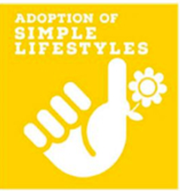
June 2023
Awareness: A simple lifestyle, when lived freely and consciously, is liberating. It is not a lesser life or one lived with less intensity. On the contrary, it is a way of living life to the full (LS. 223). We can take delight in the things that truly matter and learn to let go of what may be holding us down.
Prayer: God, help us to understand and value how simple gestures and simple lifestyles simply make it possible for others to simply live. Action: Watch: How can we live simply (5’, 3”) on https://eco-catholic.com/how-can-we-live-simply/

INDONESIA
The FDNSC sisters Indonesia, specifically Grogol Community continue to be enthusiastic, to reduce waste to the Final Disposal Site. The sisters process the waste into Eco Enzyme.
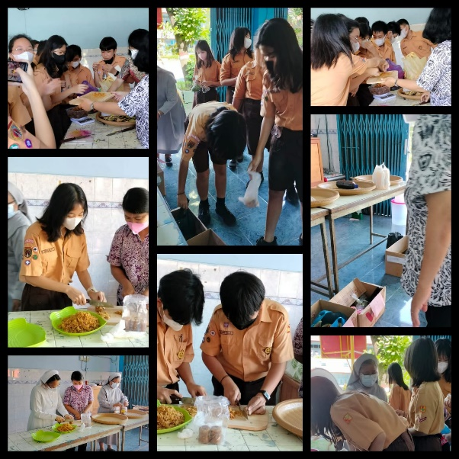
This is one of the organic waste products that has many benefits. The aim of this project is to process enzymes from organic waste that are usually thrown into trash cans into organic cleaners, or as effective natural fertilizers and pesticides.
The results of the Eco Enzyme harvest from the Grogol community.
So, this eco enzyme is the result of fermenting organic kitchen waste such as fruit and vegetable waste, sugar (brown sugar or cane sugar), and also water. This liquid is a multipurpose liquid detergent
that can be used for cleaning houses, agriculture, and for livestock.

Sr. Pauline Sutarmi as the person in charge of the Provincial JPIC and Sr. Karmelia Sumarandak FDNSC as the Principal of the Pius Tegal Junior High School, also mobilized the children to learn how to make Eco Enzyme. Preceded by a seminar on sorting and processing organic waste into eco enzymes, the children were asked to bring organic waste from their homes, and on the second day at school, they practiced Eco Enzyme. On June 3rd they will harvest eco enzyme.

AUSTRALIA

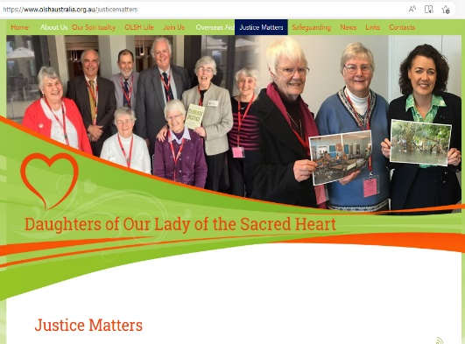
Since 2022 the Australian sisters focus has been on Laudato Si. The sisters have a committee with Sisters and members of the Chevalier Family. They have spent some time as a Province working on Laudato Si Action Plan and they have written a reflection booklet on Laudato Si. It provides material for individual and community reading, reflection and discussion which relates to the OLSH charism and Spirituality of the Heart.
In Australia they send out a regular JPIC newsletter ‘OLSH Hearts for Others’ which focusses on various issues.
These can be found on our website https://www.olshaustralia.org.au/justicematters and Facebook page.

Through this newsletter we reloaded commitments to JPIC from the Provinces at the General Chapter, September 2022, as follows:

NO | PROVINCES | COMMITMENT TO JPIC | ADDITIONAL INFORMATION
1 | Africa | Participate in meetings and activities planned by the committee, cleanliness day, reforestation at Diocesan or Parish level  Initiated by the Conference of Major Superiors in each country, contribution for solidarity effort for war zones, Green Sahel, waste treatment and recycling.  Accompaniment of girls in forced marriages, so-called witch children, orphans and vulnerable children, advocacy for the integration of these children into their families.  (collaborate with other organisations on awareness and the fight against sexual abuse in the apostolate and some of the projects where we work)  Made a commitment to read and share the Laudato Si encyclical in community and to improve rubbish disposal (waste separation)
2 | Australia | Justice: Stewardship of Creation and the Promotion of Peace: Refugees, First Nations People and Climate Justice. Information | These can be found on website https://www.olshaustralia.org.au/justicematters and Facebook page.
 |  | Kiribati Choose Life Program: In collaboration with our Sisters in Kiribati the project, ‘Empowering Women - Kiribati Choose Life,’ has been established. . The project provides funding to assist and empower the women of Kiribati, through education and training, to address and respond to climate change as it impacts on their life.
Local Initiatives:
Sisters have attended rallies in their areas and have written letters to their local government members, urging them devise policies and structures that support those rendered poor.

Welcomed Laudato Si’ and all the Sisters have been provided with prayers and resources for care of the earth to support their endeavours. Where possible, solar panels for our buildings and LED lighting have been installed.

Reducing our carbon footprint, supporting our First Nations People, commitment to the Laudato Si’ Action Platform, and reflection and community discussion around our newly produced Province JPIC series, “OLSH Hearts for Others.”
3 | Brazil | Cor America prepared a session about JPIC in the Chevalier Family in the context of Latin America. One of the sisters is a member of a team created after this session. Their role is to create a network between the Chevalier Family members in Latin America. We really appreciate the "First Friday Intention" prepared by the Tri-Generalate. It is a simple way to remind us of our commitment to JPIC.
4 | France | - We read carefully the bulletin we receive from the Generalate.  - We are committed to praying for the intentions that are proposed.  - We are concerned about social justice in the places where we work.  - A sister is committed to the service of migrants, for literacy.  - Each community makes an effort to sort waste.  - We are concerned to keep ourselves informed about all these issues of justice, peace and the integrity of creation.  We try to consume responsibly, to avoid waste.  In our purchases, we are attentive to ecological standards and favour local products.  There is always an effort to raise awareness in all our communities
5 | Indonesia | The form of assistance given to natural disaster victims in Central Sulawesi was in the form of a Scholarship Program for school children  There were several communities that were moved and put into action to care for and maintain the environment around the community
 |  | Communities collaborate with the Parishes to organize an Organic waste collection movement, by asking the parishioners to bring garbage to the church from their respective homes
 |  | Some communities have also started making compost and Eco Enzymes, starting from sorting organic and non-organic waste.
 |  | The schools try to reduce the use of plastic bags, forbid Styrofoam lunch boxes and does not provide drinks in plastic bottles.
Papua Region is also committed to JPIC as an expression of Social Solidarity to Papua people. The care of the Sisters in the Papua Region towards the community served includes:
1. Fight for law enforcement and respect for human rights by prioritizing the rights of the weak and the oppressed.
 |  | 2. Maintain the integrity of creation
 |  | 3. Support all forms of socio-political dialogue that is open and dignified for the realization of true democracy in the land of Papua
 |  | 4. Society empowerment
6 | Ireland | We see the need to be open to change when it comes to caring for our environment because we realize that, unconsciously, we have become part of a wasteful generation.
7 | Kiribati | Gardening is one of the things that we encourage in communities, planting both flowers, trees and vegetables
 |  | Sometimes we help with cleaning up of plastics in the villages and we ceased to sell ice blocks and pop rice served with plastics. We support our government in trying to discourage the import of plastics, especially plastic bags.
 |  | With our work with abused women and children we look after them and collaborate with police, social workers and counsellors till their cases are put to court or for prosecution
 |  | During the lock down the MSC organised helping poor people with food and we contributed too to help handicapped people in their village and single mothers whose husbands left them or died. This is more to help the poor. Some of us signed letters supporting groups on family, Citizen Go, Avaaz and these groups deal with injustice issues.
8 | Netherlands | Father Jan Jetse Bol msc ensures that all members of the Chevalier Family, for the first Friday of the month, receive prayer intentions that draw attention to Justice, Peace and Integrity of Creation
 |  | The Hartopweg movement, a new initiative with associates, offers reflection programmes in which we can participate
 |  | Pay attention to the JPIC Bulletins of Generalate and the CMBR (Commission of Missionary Movement of Religious), which raise awareness of these themes. We invest in green, use green energy (‘green choice’) and separate waste. We also pay attention to climate change and try to live sustainably.
9 | Papua New Guinea | Some sisters are engaged in JPIC issues such as empowerment of vulnerable women and children, not in a big way but in everyday issues that come with their apostolates of village or school in which they work. Some assistance is given by helping to educate poor students both in the rural and urban areas
 |  | Assisting with women who are widowed and unable to educate, feed and clothe their children.
 |  | Education and assistance to HIV/AIDS victims. Counselling and instructions to give help to cope with the disease
 |  | Education of our sisters on the Environment i.e., how we can do something, no matter how small to save our Mother Earth.

If you have other commitments that are not included in the above, please send them to the Generalate.

Thus our first edition of the bulletin. Thank you, sisters, for your willingness to translate and put into action this newsletter. Thank you all for your participation. Let us be united and work together for the JPIC movement.

